WYKE REGIS AND LANEHOUSE PRACTICE FRIENDS (WITH CHICKERELL): UPDATE JUNE 2020

TUESDAY TEAS TOGETHER

Sadly we are not yet in a position to recommence the Tuesday Teas Together held weekly at the Wyke Regis surgery but once we are we will update the practice website and put notices up in each of the three surgeries.

PRACTICE ALLOTMENT
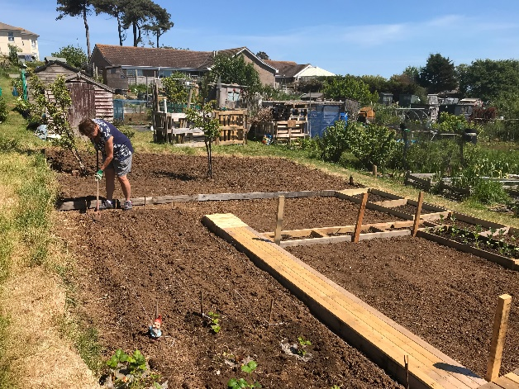
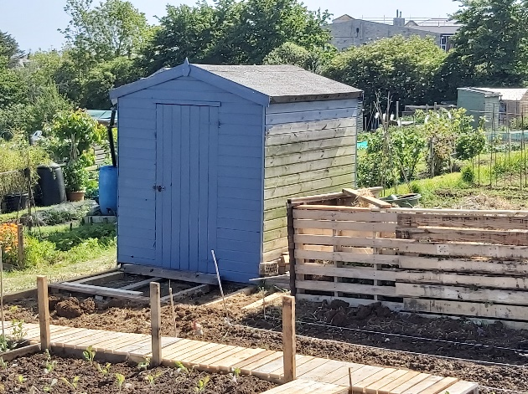

In summer 2019 Teresa Cuff was asked if the Friends would be interested in taking on responsibility for half an allotment situated at the top of Rylands Lane. The intention was to provide patients from the practice, and their carer’s opportunities to contribute to caring for the allotment (plot 40A), sharing produce or somewhere for patients to sit and enjoy the views. The Friends supported this initiative and planned to start work cultivating the ground in early 2020 although were originally thwarted by the very wet weather during the early months of 2020 and then the Corona Virus.

However, despite (or because) of the current restrictions Teresa and her husband recently began to prepare the ground and began the planting. Currently this includes potatoes, tomatoes, strawberries, broad beans and courgettes. Additionally Rosemary donated raspberry, gooseberry, redcurrant and blackcurrant bushes, tomatoes and a fennel which have also been planted. We have a shed to store the tools, plant pots etc and Sue and Tina have been up to help with Sue on hoeing duty and Tina watering the plants

At the moment, because of the restrictions and the need to observe social distancing, the allotment is not yet open to patients and their carers. However, we hope to be able to welcome patients to join us to help with the cultivation of the ground or just sit and enjoy the view and listen to the birds as soon as this is allowed. Some patients have already expressed an interest in joining us and we will let them know when that will be possible and at that point we can ask the practice patients to let us know if they would like their name adding to the list.

BEFRIENDING

Kathy and Pennie are our befrienders. Currently they are not able to visit patients in their homes and take them out to appointments, shopping for coffee or just go for a walk but hope this initiative will begin again at some point.

PRACTICE DIRECTORY OF SERVICES

The practice “DIRECTORY OF SERVICES FOR PATIENTS, CARERS, AND FAMILIES” includes two sections on information for Support and Advice services. Whilst there is a copy of the directory in a red colder in each of the practice surgeries at Chickerell, Lanehouse and Wyke the directory can also be accessed via the practice website at:

https://www.wykeregisandlanehousemedicalpractice.co.uk/page1.aspx?p=16&t=4

